Bank Loan KPI’s

1. ---total loan application

select COUNT(id) as 'total loan application' from bank_loan_data



1. ----- MTD loan application

select COUNT(id) as 'MTD loan application' from bank_loan_data

where MONTH(issue_date)=12 and YEAR(issue_date)= 2021



1. -----previous month PMTD loan application {(MTD-PMTD)/PMTD}

select COUNT(id) as 'PMTD loan application' from bank_loan_data

where MONTH(issue_date)=11 and YEAR(issue_date)= 2021



1. ---- total funded amount

select sum(loan_amount) as 'total funded amount' from bank_loan_data



1. ---- total funded amount MTD

select sum(loan_amount) as ' MTD total funded amount' from bank_loan_data

where MONTH(issue_date)= 12 and YEAR(issue_date)=2021



1. ---- total funded amount PMTD

select sum(loan_amount) as ' PMTD total funded amount' from bank_loan_data

where MONTH(issue_date)= 11 and YEAR(issue_date)=2021



1. -----total recieved amount

select sum(total_payment) as 'total recieved amount' from bank_loan_data



1. ---- total recieved amount MTD

select sum(total_payment) as ' MTD total recieved amount' from bank_loan_data where MONTH(issue_date)= 12 and YEAR(issue_date)=2021



1. ---- total recieved amount PMTD

select sum(total_payment) as ' PMTD total recieved amount' from bank_loan_data

where MONTH(issue_date)= 11 and YEAR(issue_date)=2021



1. -------average interest rate across all loans

select round(avg(int_rate), 4) *100 as 'average interest rate' from bank_loan_data



1. -------MOM average interest rate across all loans

select round(avg(int_rate), 4) *100 as 'MOM average interest rate' from bank_loan_data

where month(issue_date)= 12 and YEAR(issue_date)=2021



1. -------PMTD average interest rate across all loans

select round(avg(int_rate), 4) *100 as 'PMTD average interest rate' from bank_loan_data where month(issue_date)= 11 and YEAR(issue_date)=2021



1. -------DTI average of all loans

select round(avg(dti), 4) *100 as 'average dti' from bank_loan_data



1. -------MOM dti of all loans

select round(avg(dti), 4) *100 as 'MoM dti' from bank_loan_data

where month(issue_date)= 12 and YEAR(issue_date)=2021



1. -------PMTD dti of all loans

select round(avg(dti), 4) *100 as 'PMTD dti' from bank_loan_data

where month(issue_date)= 11 and YEAR(issue_date)=2021



1. ---------good loan percentage

select

(COUNT (case when loan_status = 'Fully Paid' or loan_status = 'Current' then id end)*100)

/

count(id) as 'Good_loan_percentage'

From bank_loan_data



1. ---------- Good Loan Applications

select COUNT(id) as 'Good loan application' from bank_loan_data

where loan_status= 'Fully Paid' or loan_status='Current'



1. ----------Good Loan Funded Amount

select sum(loan_amount) as 'Good loan Funded Amount' from bank_loan_data

where loan_status= 'Fully Paid' or loan_status='Current'



1. ----------Good Loan Total Received Amount

select sum(total_payment) as 'Good loan Total Received Amount' from bank_loan_data

where loan_status= 'Fully Paid' or loan_status='Current'



20.------Bad Loan Application Percentage

select

(COUNT (case when loan_status = 'Charged off' then id end)*100)

/

count(id) as 'Bad_loan_percentage'

From bank_loan_data



1. --Bad Loan Applications

select COUNT(id) as 'Bad loan application' from bank_loan_data

where loan_status= 'Charged off'



1. --Bad Loan Funded Amount

select sum(loan_amount) as 'Bad loan Funded Amount' from bank_loan_data

where loan_status= 'Charged off'



1. --Bad Loan Total Received Amount

select sum(total_payment) as 'Bad loan Total Received Amount' from bank_loan_data

where loan_status= 'Charged off'



23.------loan status

SELECT

loan_status,

COUNT(id) AS LoanCount,

SUM(total_payment) AS Total_Amount_Received,

SUM(loan_amount) AS Total_Funded_Amount,

AVG(int_rate * 100) AS Interest_Rate,

AVG (dti* 100) AS DTI

FROM

bank_loan_data

GROUP BY

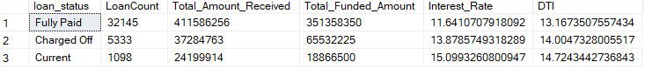

24.-------Monthly Trends by Issue Date

select

MONTH(issue_date) as 'Month_number',

DATENAME(month,issue_date) as Month_name,

COUNT(id) as Total_Loan_Applications,

SUM(loan_amount) as Total_Funded_Amount,

SUM(total_payment) as Total_Amount_Recieved

from bank_loan_data

group by MONTH(issue_date), DATENAME(month,issue_date)

order by month(issue_date)

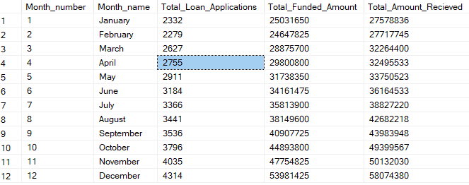

25. --Regional Analysis by State

select

address_state as State,

COUNT(id) as Total_Loan_Applications,

SUM(loan_amount) as Total_Funded_Amount,

SUM(total_payment) as Total_Amount_Recieved

from bank_loan_data

group by address_state

order by address_state

